Project Report
Currency Converter Calculator
Submitted By:
JEEYA
Course/Subject:

[Course Name, e.g., Introduction to Programming]
Date:
November 24, 2025

Contents
1 Introduction
2 Problem Statement
3 Functional Requirements
4 Non-functional Requirements
5 System Architecture
6 Design Diagrams
7 Design Decisions & Rationale
8 Implementation Details
9 Screenshots / Results
10 Testing Approach
11 Challenges Faced
12 Learnings & Key Takeaways
13 Future Enhancements
14 References

Introduction
The Currency Converter Calculator is a simple command-line application developed in Python. Its primary function is to perform quick conversions between three major global currencies—US Dollar (USD), Euro (EUR), and British Pound (GBP)—and the Indian Rupee (INR). The application is designed to be user-friendly, providing a menu-driven interface for easy navigation and computation.

Problem Statement
Develop a command-line utility that accurately calculates currency conversions between USD, EUR, and GBP, and the INR, based on a set of fixed exchange rates. The application must be modular, easy to use, and clearly present the conversion results to the user.

Functional Requirements
Functional requirements describe what the system must do.
- F1. Currency Conversion: The system must accurately convert a given amount from:
  - USD to INR
  - EUR to INR– GBP to INR
  - INR to USD
  - INR to EUR
  - INR to GBP
- F2. Input Handling: The system must accept user input for the desired conversiontype and the amount to be converted.
- F3. Output Display: The conversion result must be displayed to the user, rounded totwo decimal places for currency format.
- F4. User Interface: The system must present a clear, numbered menu of conversionoptions.
- F5. Continuous Operation: The system must allow the user to perform multiple conversions until explicitly choosing to exit.

Non-functional Requirements
Non-functional requirements describe how the system performs.
- NFR1. Usability: The application must have an intuitive and easy-to-use command-line interface.
- NFR2. Maintainability: The code must be well-structured with defined functions foreach conversion type, making it easy to update exchange rates.
- NFR3. Performance: Conversions should be calculated and displayed instantly.
- NFR4. Robustness: The application should handle non-numeric or invalid menu inputs gracefully.

System Architecture
The system uses a Monolithic Architecture model, specifically a single-file application structure. It is built entirely on the Python programming language and runs as a standalone script on the command line.
- Presentation Layer: Handled by print() and input() functions for user interaction via the console.
- Business Logic Layer: Implemented by the six defined conversion functions (e.g.,usd_to_rupee, rupee_to_usd) which contain the core conversion formulas using fixed exchange rates.
- Control Flow: Managed by a while loop that continuously prompts the user, and an if/elif/else structure that directs the program to the correct conversion function based on the user’s menu choice.

Design Diagrams
Given the simplicity of a single-file Python script, we focus on the most relevant behavioral and structural diagrams.

[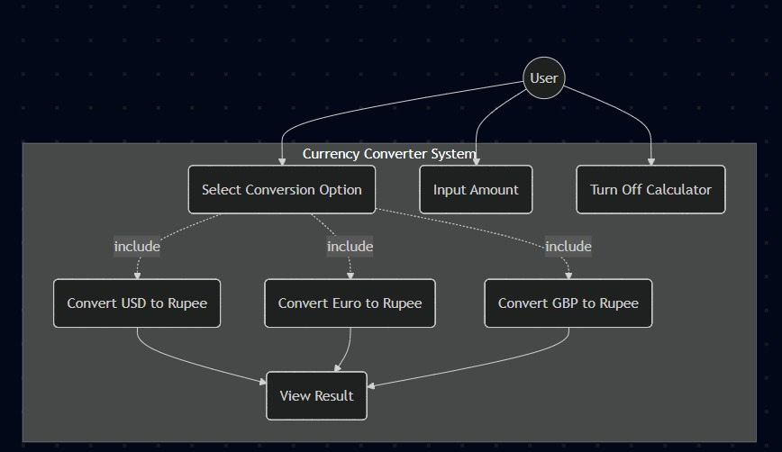 USER CASE DIAGRAM
Diagram showing user interaction with conversion options.
Figure 1: Use Case Diagram

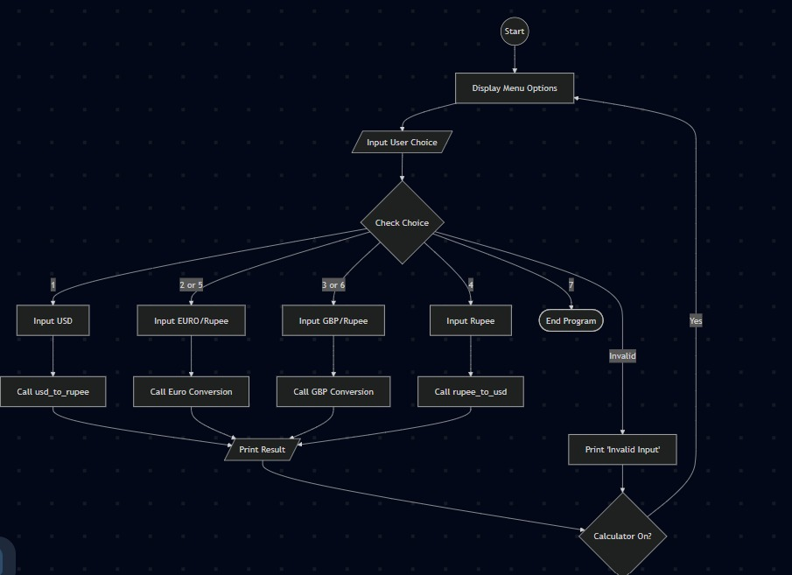WORK FLOW DIAGRAM
Flowchart showing the Start -> Menu -> Decision -> Calculation -> End flow.
Figure 2: Workflow Diagram

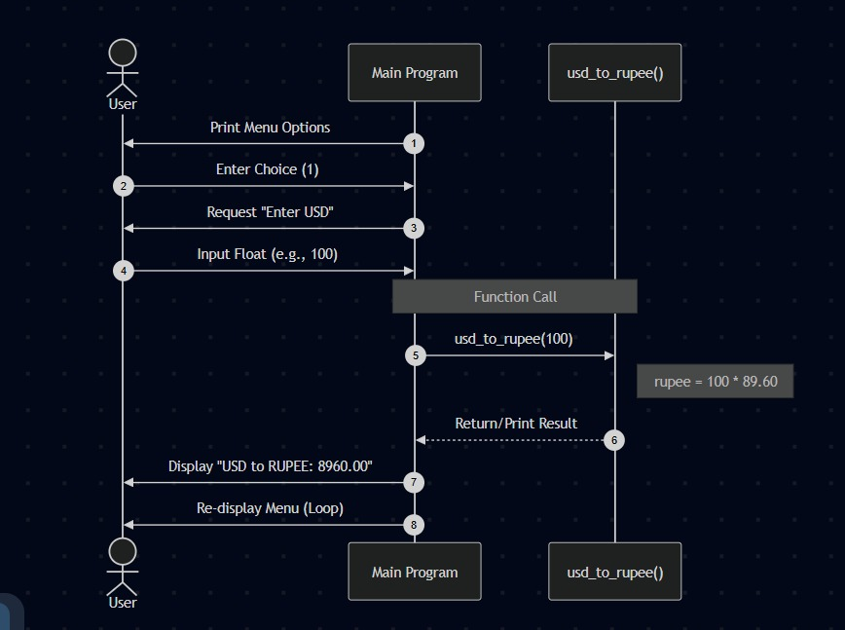
SEQUENCE DIAGRAM
Sequence showing the interaction for converting USD to Rupee.
Figure 3: Sequence Diagram

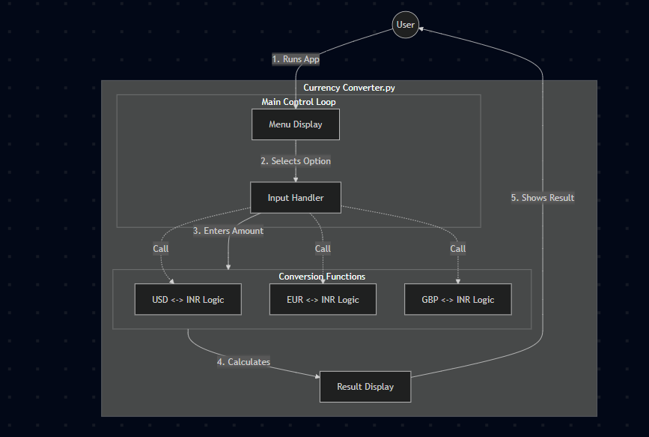
Diagram showing the main functions and control block.
Figure 4: Component Diagram

Design Decisions & Rationale
For this project, I decided to use a modular approach, creating separate functions for each currency pair to ensure the code was organized and easy to test. I opted for fixed exchange rates to minimize external dependencies, allowing the application to run offline. To enhance usability, I implemented a continuous while loop, so users don't have to restart the script for every new calculation. Finally, all inputs are cast to floats to handle decimal values accurately, which is essential for financial calculations.

Implementation Details
The project is implemented in Python 3.

Exchange Rates Used
- 1 USD = 89.60 INR
Decision | Rationale
Fixed Exchange Rates | For simplicity and to focus on core programming logic, rates are hardcoded. This avoids the complexity of API calls for real-time rates.
Modular Functions | Each conversion pair is encapsulated in a separate function  (e.g., usd_to_rupee). This promotes reusability and readability.
While Loop for Control | A while loop is used to keep the calculator running indefinitely until a break condition is met. This improves usability.
Rounding (2 Decimals) | The round(..., 2) function is used to ensure the output adheres to standard currency formatting.
- 1 EUR = 103.14 INR• 1 GBP = 117.45 INR

Conversion Logic
- Foreign to Rupee: rupee = amount * rate
- Rupee to Foreign: foreign = amount / rate

Input Validation
A basic validation check (if currency > 0:) is included in each function to ensure nonnegative amounts are processed.

Screenshots / Results
[INSERT Menu Display HERE]
Screenshot showing the initial output of the menu options.
Figure 5: Menu Display
[INSERT USD to INR Conversion HERE]
Screenshot showing the user inputting choice 1 and result.
Figure 6: USD to INR Conversion
[INSERT INR to EUR Conversion HERE]
Screenshot showing the user inputting choice 5 and result.
Figure 7: INR to EUR Conversion

Testing Approach
A Unit Testing approach was used, focusing on the core calculation functions.
- Positive Case: Input: 10 USD. Expected Output: 896.00 INR (_{10×89.60}).
- Edge Case (Zero): Input: 0 USD. Expected Behavior: No output (due to validationcheck).
- Large Value Case: Input: 1000 USD. Expected Output: 89600.00 INR.
Manual Testing: The application was manually tested by running the script and verifying the results against external simple calculations for each of the six conversion paths.

Challenges Faced
- Handling User Input Errors: A primary challenge was ensuring the program didn’t crash on invalid input (e.g., user enters text instead of a number).
- Resolution: Implemented basic input validation (future enhancement involves tryexcept blocks).
- Maintaining Precision: Ensuring the conversion results were correctly rounded to two decimal places required using the round() function effectively.

Learnings & Key Takeaways
- Modular Programming: Gained practical experience in breaking down a problem into reusable and testable functions.
- Control Flow: Reinforced understanding of while loops and if/elif /else structures.
- Data Types: Understood the necessity of explicitly converting input from strings tofloating-point numbers.

Future Enhancements
- Real-Time Exchange Rates: Implement an API call to fetch current exchange rates instead of fixed values.
- Error Handling: Implement robust try-except blocks to prevent crashes on nonnumeric input.
- Exit Functionality: Properly implement the option to turn off the calculator using a break statement.
- More Currencies: Expand the calculator to include additional global currencies (e.g., JPY, AUD).

References
- Python Documentation (docs.python.org)
- Currency Rates source: [Hypothetical exchange rates as of Submission Date]

